

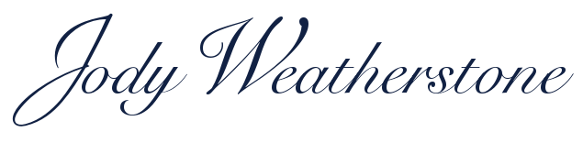

BIOGRAPHY

Soprano Jody Weatherstone's versatility and flexibility as a singer and an actress have led her to perform in a wide range of genres, from musical theater to oratorio. Her vibrant and refined soprano has been reviewed with enthusiasm throughout the New York region.  
  
Jody has appeared as a soloist in many choral works including the Bach and Rutter *Magnificat*, the *Requiem* masses of Brahms, Fauré and Rutter, Haydn’s *Theresienmesse* and *Kleine Orgelmesse*, Beethoven’s *Mass in C*, Vaughan Williams' *Dona Nobis Pacem*, and the Vivaldi *Gloria*. She has appeared as the soprano soloist in the *Messiah* many times, including at the West Point Cadet Chapel, conducted by Craig Williams, and in its entirety with the Cathedral Choir and the American Chamber Orchestra under the baton of Robert F. Davis. Jody is a frequent guest soloist with Classic Choral Society under the direction of Janiece Kohler, having performed as a soloist in fifteen major choral works with the organization. She has also appeared with the Northern Dutchess Symphony, Newburgh Symphony, New York Wind Symphony, Delaware Valley Opera, Allegro Orchestra, Pro Arte Chorale, and Tuxedo Performing Arts Group, among others, including a performance at Alice Tully with the NYU Choral Arts Society and at CAMI Hall in recital.

Jody’s musical theatre credits include the first national tour of Stephen Sondheim's *Into the Woods* directed by James Lapine, in which she performed both Cinderella and Little Red Riding Hood, followed by a European tour as Christine in Ken Hill’s operatic adaptation of *Phantom of the Opera*. Additional performance venues include the Duo Theatre and Sanford Meisner Theatre in NYC, Caldwell Theatre in Florida, Northwoods Theatre in Texas, and Oldcastle Theatre in Vermont.

Jody’s education is varied and far reaching; a graduate of New York University with a degree in Voice and Theatre, she is also an alumnus of the Institute of Culinary Education. She has combined her performing experience with her knowledge of the culinary arts in several television food venues, as well as writing for numerous food publications and cookbooks. Jody is a Level II Reiki practitioner, is certified in Somatic Voicework (The LoVetri Method), and completed her 200-hour yoga teacher training from Vastu. She also maintains a private voice studio in Warwick, NY.

